CS 255 System Design Document

Agomani Das
Agomani.das@snhu.edu
Southern New Hampshire University

UML use case diagram
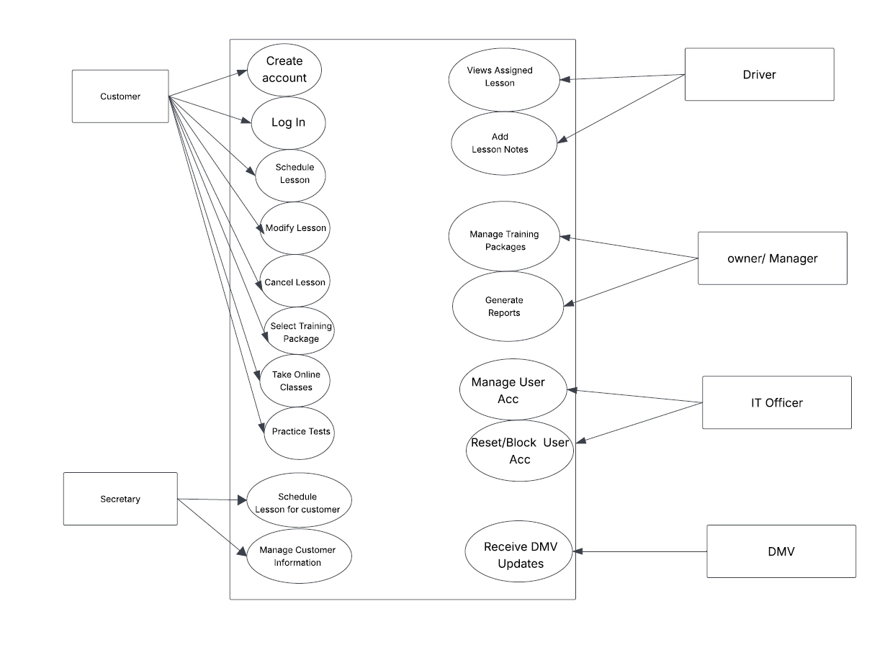

UML Diagrams

UML Use Case Diagram

This activity diagram shows how a customer goes about making a booking for a driving lesson using the DriverPass application. Prior to the creation of the booking, the application will verify the availability of the instructor and the vehicle at that particular time. In case there is no availability at the selected time, the customer may select other dates and times.

UML Activity Diagrams

Activity Diagram 1: Schedule a Lesson

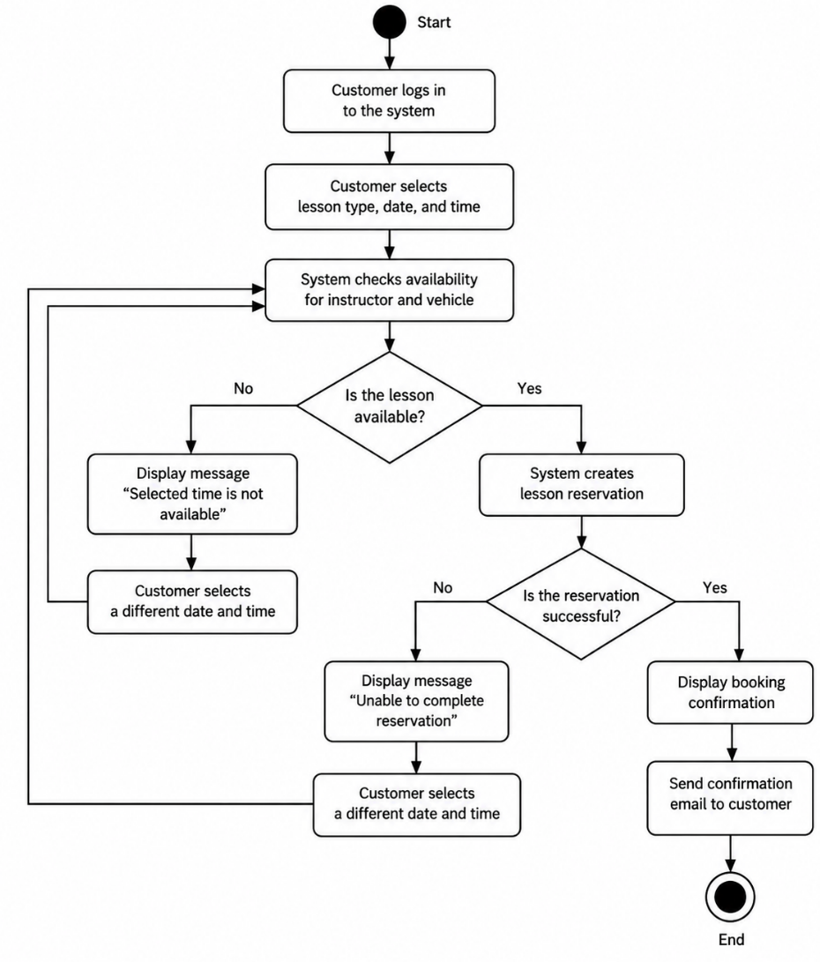
UML Activity Diagram 2: Modify/Cancel a Lesson
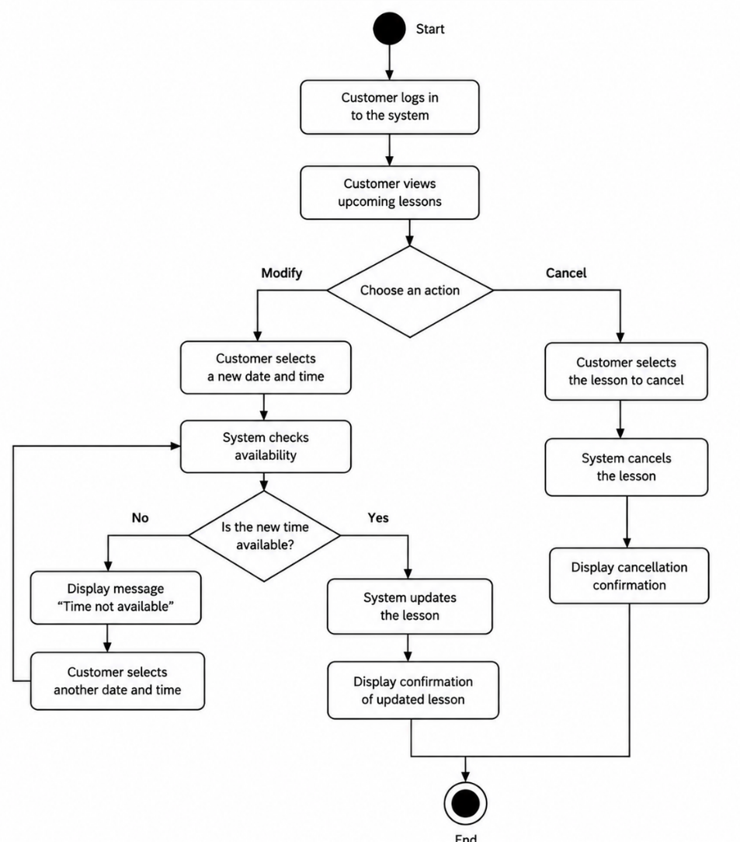

The above activity diagram explains the way in which the customer can change or cancel the existing driving lesson. If changing the lesson, the system checks for the availability of the time slot before making changes to the reservation. In case the time slot selected by the customer is not available, then he may select any other time slot.

UML Sequence Diagram

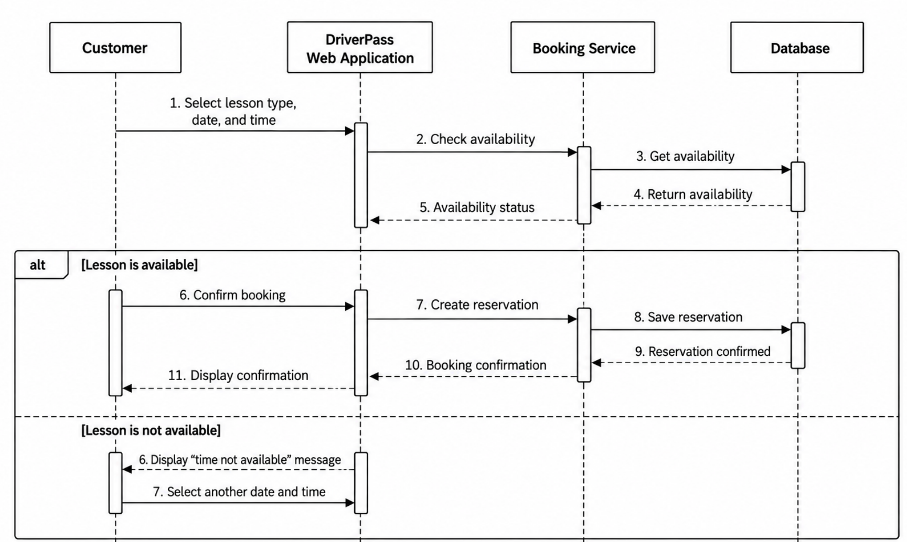

This sequence diagram illustrates the process of handling lesson booking requests using the DriverPass software system. The application queries for availability using the Booking Service and Database. In the case of the availability of the lesson, the system stores the booking and provides the confirmation message. In case of unavailability, the customer is prompted to pick another date and time.

UML Class Diagram

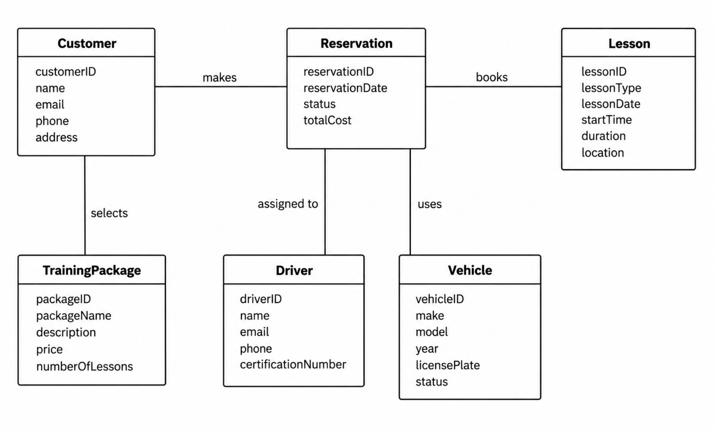

The above UML Class Diagram shows the classes used within the DriverPass System and how they relate to each other. The Customer class holds information about customers. The Reservation class handles booking for lessons. The Lesson class stores lesson information. The Driver and Vehicle classes hold information about the resources booked by a Reservation. The TrainingPackage class holds information about training packages including their cost and number of lessons.

Technical Requirements

Hardware Requirements
DriverPass software shall be compatible with desktop computers, laptop computers, tablets, and mobile devices. A stable internet connection is needed for accessing and updating information on the system. Server infrastructure shall host the cloud computing infrastructure for running applications, database storage, and periodic data backup.

Software Requirements
DriverPass software requires the development of a web-based application and a database, along with the use of a suitable web browser. It must provide the functionality of user registration, booking of lessons, handling training packages, taking online classes, doing practice tests, and generating reports.

Tools and Technologies
Development tools would be required to develop, test, and maintain the application and database. The system must be able to generate reports that can be downloaded in Excel-compatible format. The system must also have the capability to make authorized changes to the rules and policies of the DMV.

Infrastructure and Security
The cloud-based infrastructure will enable authorized users to use the system from various locations. The security measures will entail encrypted connections, proper access controls, backups, and loggings. The system is supposed to track the persons responsible for creating, editing or canceling reservations in order for the management to review the activity reports. The data changes should be done when the computer is connected to the internet.

